📌 **Project Title:**

# Deploy a Multi-Page Business Website on AWS EC2 using Git, Linux & Nginx

📅 **Duration: 4–5 Days**

📈 **Difficulty: Medium**

🎯 **Objective:**

Build and deploy a complete static website using GitHub → EC2 → Nginx.

This project will teach you real DevOps workflow, Linux commands, server setup, and debugging skills.

# 🟦 DAY 1 — Website Creation + GitHub Setup

## Task 1: Build a Multi-Page Website (4–5 Pages)

Create these pages:

* Home



* About



* Services



* Contact



* (Optional) Gallery/Portfolio

Use **HTML + CSS** only.

You must create the website yourself (no templates allowed).

## Task 2: Upload to GitHub

1. Create a new repo: **business-website-project**

1. Upload all pages

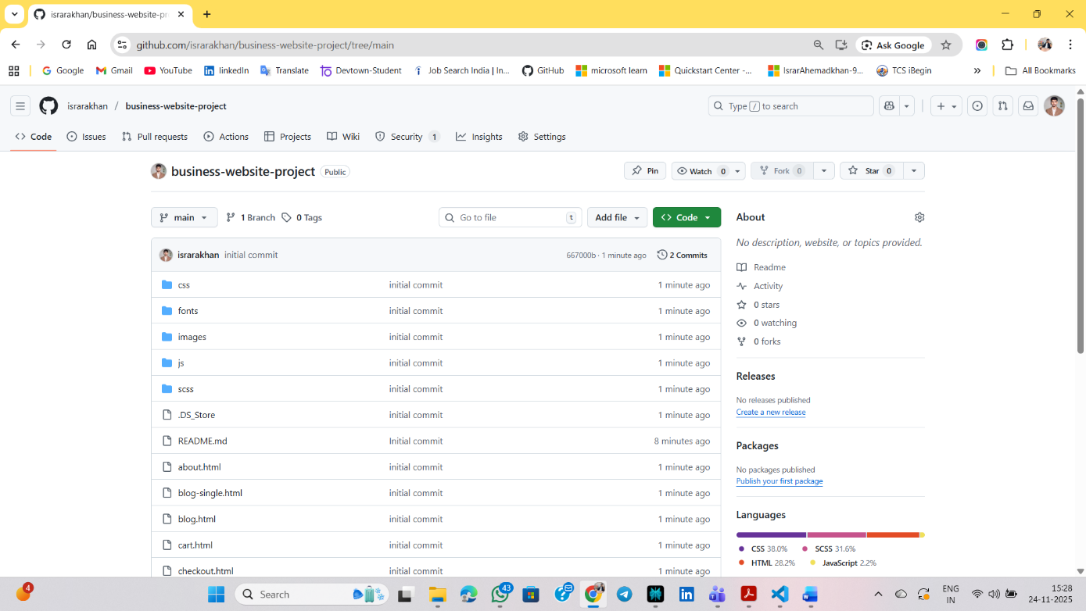

1. Add a README including:

○ Project description

Coffee Blends is a responsive coffee shop and restaurant website that showcases the brand’s story, menu, and products while supporting basic e-commerce features like product listing, cart, and checkout pages. project includes dedicated sections for online ordering, table booking, blog posts, and customer testimonials to provide a complete digital experience for a modern café business.

○ Tech used

**HTML+CSS+JavaScript**

○ Screenshots (local view)

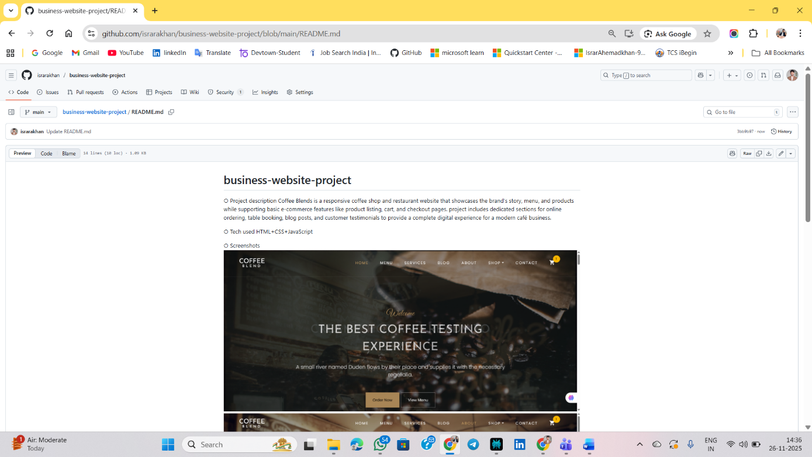

# 🟦 DAY 2 — EC2 Setup + Linux Setup

## Task 1: Launch EC2 Instance

* Ubuntu 22.04

* t2.micro

* SSH (22) + HTTP (80)

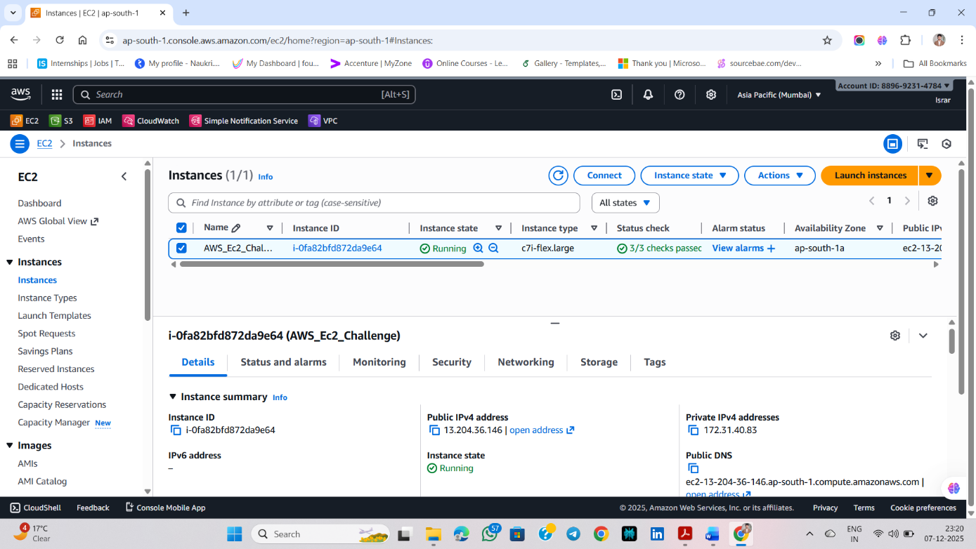

* Attach Elastic IP

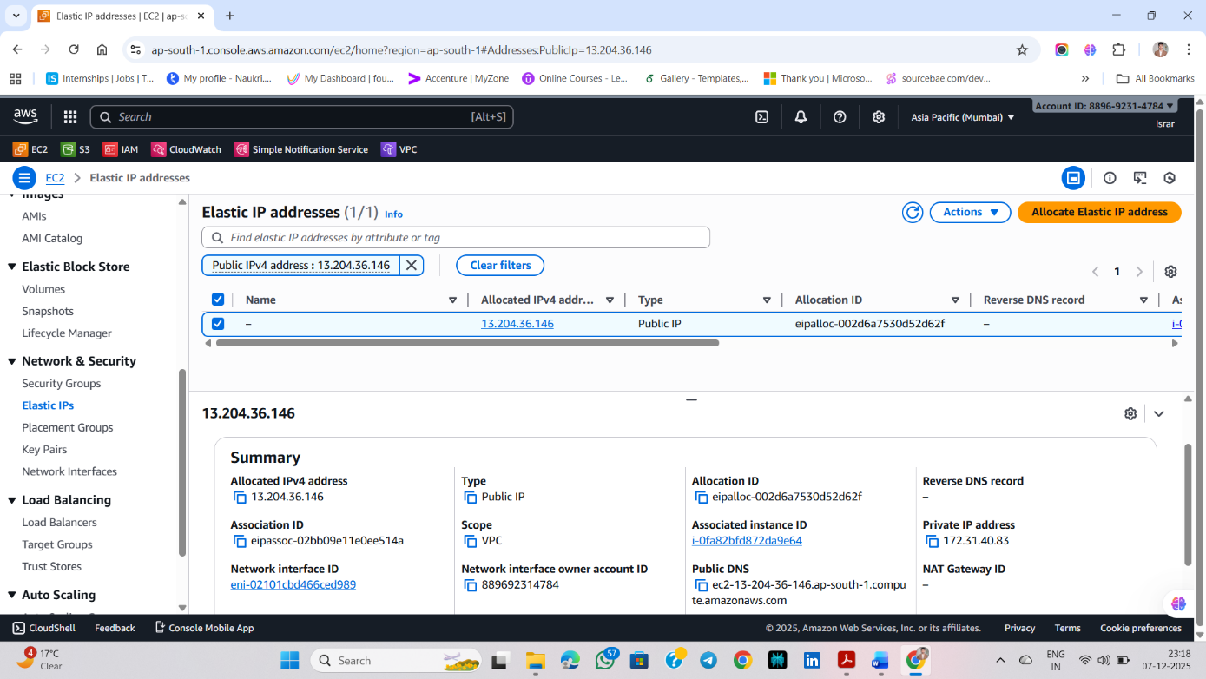

## Task 2: SSH Connection

* chmod 400 key.pem
* ssh -i key.pem ubuntu@<your-elastic-ip>

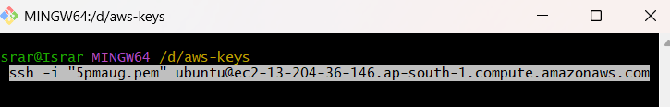

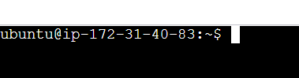

## Task 3: Install Nginx

* sudo apt update



* sudo apt upgrade -y

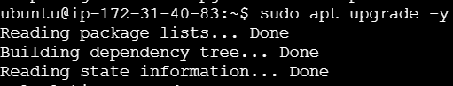

* sudo apt install nginx -y
* sudo systemctl status nginx

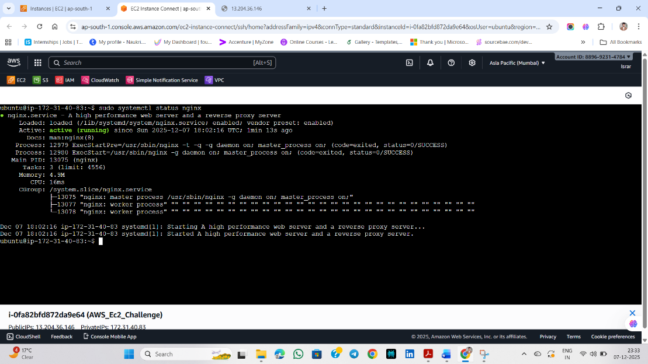

# 🟦 DAY 3 — Git Pull + Nginx Configuration

**Task 1: Install Git**

* sudo apt install git -y

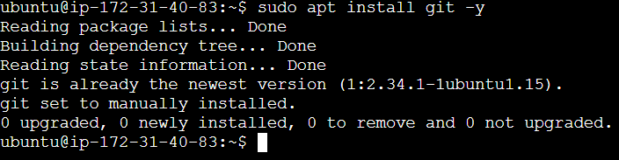

**Task 2: Clone Your GitHub Repository**

* git clone <your-repo-url>

<https://github.com/israrakhan/business-website-project.git>

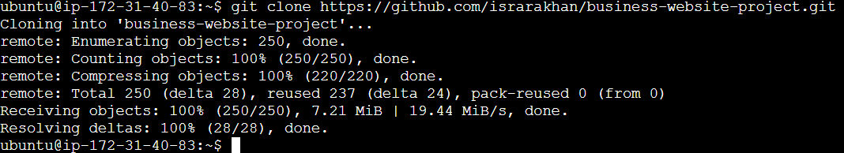

## Task 3: Move Website Files to Nginx Root

* sudo rm -rf /var/www/html/*

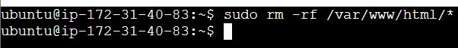

* sudo mv business-website-project/* /var/www/html/



## Task 4: Restart Nginx

● sudo systemctl restart nginx

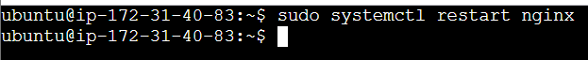

# 🟦 DAY 4 — Debugging & Fixing Issues

Fix all common issues:

* CSS not loading

* Broken images

* Wrong file paths

* 404 errors

* Missing assets

* Permission issues:

sudo chmod -R 755 /var/www/html

●

**Goal:** Make the entire website fully working on AWS.

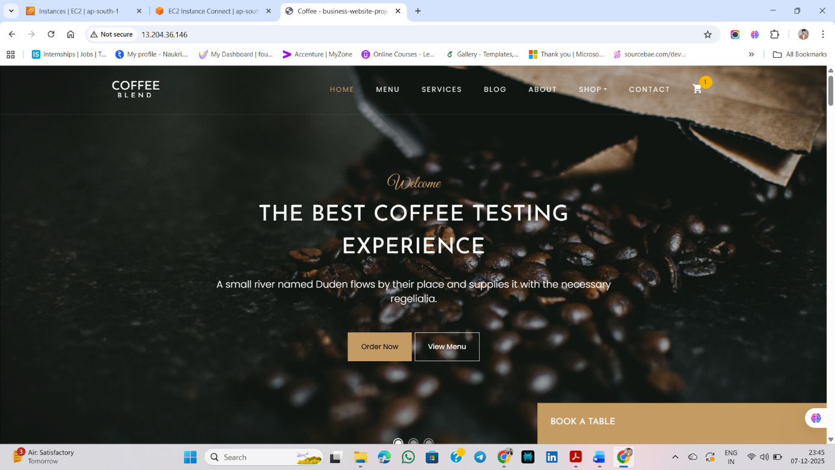

# 🟦 DAY 5 — Testing + Final Submission

## Task 1: Test Website Live

Open your website:

● http://<your-elastic-ip>

<http://13.204.36.146/>

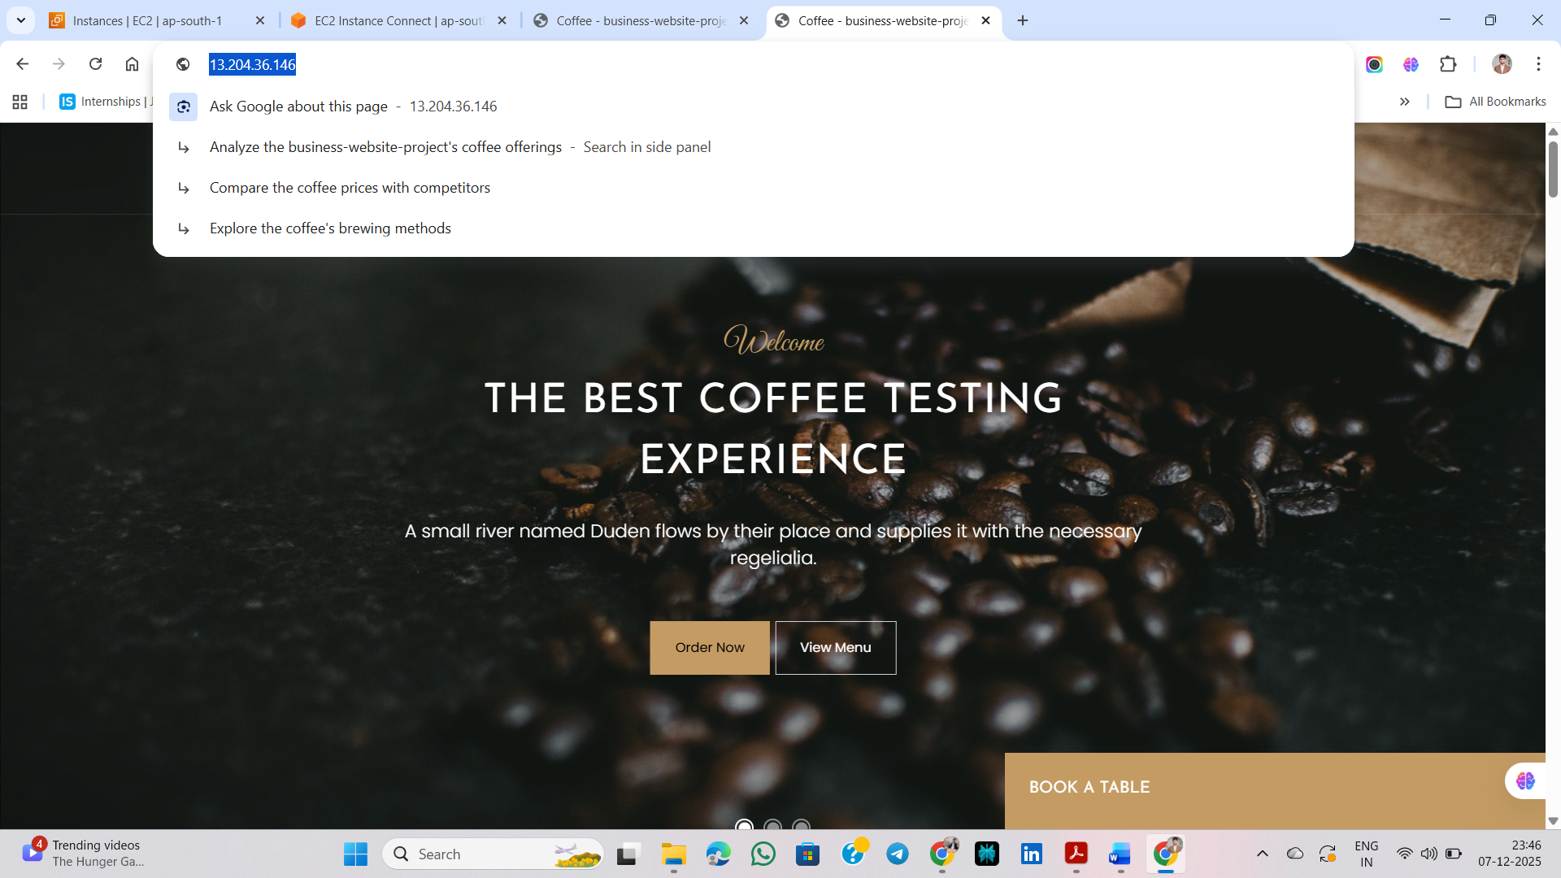

## Task 2: Prepare Your Progit baject Report

Create: **project-report.txt**

Include:

* Overview

* Step-by-step process

* Errors you faced

* How you solved them

* Final screenshots

## Task 3: Create Submission Repository

Repo name: **devops-project-submission**

Add:

* project-report.txt

* website-github-link.txt (your website repo)

* live-website-link.txt (Elastic IP link)

* Folder: **screenshots/**

○ EC2 dashboard

○ Elastic IP

○ Terminal SSH

○ Git clone

○ Nginx status

○ Final live website

# 🎉 Final Output

By the end of this project, you will have:

* A 5-page website

* A working EC2 server

* Elastic IP

* Git → EC2 workflow

* Nginx hosting skills

* Linux command experience

* Fully deployed live website

* Complete project report for portfolio

●